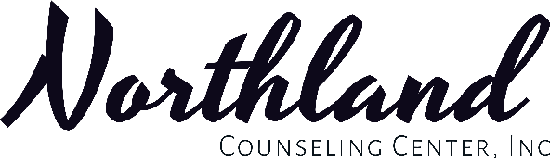
Minor Proxy Form for ages 12 - 17
A proxy authorization means that you give another person full access to your Credible Client Portal medical record through an online Client Portal account. It is as if they were you. This might be a parent or guardian who helps you take care of your health. You must complete the whole form. Please print clearly.
Client Information:
Patient Name:
*Last: *First: *Middle initial:
*Date of Birth: Age:
*Street Address:
*City: *State: *Zip: Phone Number:
Proxy Information - You must complete a separate form for each proxy request.
Proxy Name:
*Last: *First: *Middle initial:
*Date of Birth:
*SSN Last Four Digits: *Phone:
*Street Address:
*City: *State: *Zip:
*Legal Relationship to the Client:
Northland Counseling Center, Inc. can release health information for the client to the proxy listed above through an online Client Portal account.
It is understood that:
- For minors 0 to 11 years old, the proxy will have full access to the minor’s Client Portal medical record until their 12th birthday.
- For minors 12 to17 years old, if the minor does not sign this form, the proxy will only see a part of their Client Portal medical record.
- For minors 12 to 17 years old who sign this form, the proxy will have full access to their Client Portal medical record for one year. The proxy will need to fill out a new authorization form each year to renew access.
- Minors 12 to 17 years old can change their mind about proxy access to Client Portal at any time by letting Northland Counseling Center, Inc. know in writing. When Northland Counseling Center, Inc. gets the note, the change will be made no later than 3 business days. The change will not apply to information that has already been released before the effective date.
- Minor Patient Proxy Authorization ends when a patient turns 18 years old.
- Northland Counseling Center, Inc. cannot be responsible for the privacy of information given to the proxy. Northland Counseling Center, Inc. cannot prevent the proxy from giving information to another person. At that time, the information is no longer protected by federal and state privacy rules.
- If I do not sign this form, Northland Counseling Center, Inc. will still provide treatment to the client. This form will not affect payment, enrollment, and eligibility for benefits.
- You must complete, sign, and date this form for it to be valid. A photocopy, fax or electronically scanned and transmitted image is the same as the original.
- You can have a signed copy of this form, at your request.
- For the proxy to gain access to your Client Portal account, the proxy must activate the account with the code they will be given. The proxy must confirm that they have read and agree to the Northland Counseling Center, Inc. Client Portal Terms and Conditions. These Terms and Conditions apply to each use.
- I understand additional medical records may be requested through the Northland Counseling Center, Inc. Medical Records Office.
We attest that we are the individuals identified on this document and we agree to the information outlined above.
*Signature of Minor between the age of 12-17 granting the Proxy full access to Client Portal:

Today’s Date:
*Signature of Proxy: Today’s Date:

(*) Indicates required information.
Please email completed forms to the following email address: clientportal@northlandcounseling.org
Some features are not available through client portal at this time and we are continually working to improve this and add features as we are able.

