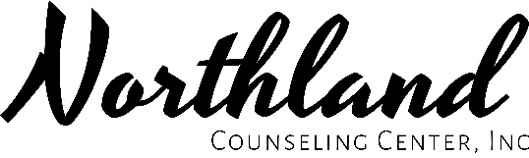

Transportation Notification

In the event that you and/or your child who is receiving services through Northland Counseling Center, Inc. becomes injured while being transported, appropriate action will be taken immediately.

In the case of an adult:

In the case of a minor injury, and if the client has a guardian, the guardian will be notified as soon as possible by the client and/or staff. If the adult client does not have guardian, staff will ask if they would like anyone notified of the minor injury.

Staff can choose to not transport adult clients.

In the case of a child:

In the case of a minor injury, staff will notify the parent/guardian by calling the parent/guardian immediately and/or as soon as able.

Staff can choose to not transport children if they do not feel the child can follow the rules and/or remain safe in the vehicle.

For all clients:

In the event that an injury occurs that requires medical attention, staff at Northland Counseling Center, Inc. will contact 9-1-1 immediately.

